
Assignment 2
ADDB7311

October 7, 2024
ST10393280
Daniel Luke James

Table of Contents
Question 1 9
Question 2 14
Question 3 15
Question 4 16
Question 5 17
Question 6 18
Question 7 19
Question 8 22
SQL Code 23
ACADEMIC HONESTY DECLARATION 43
43
Reference List 44

Question 1 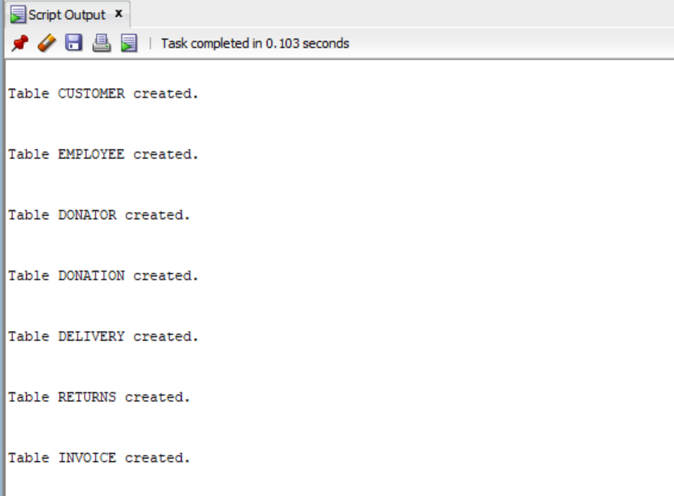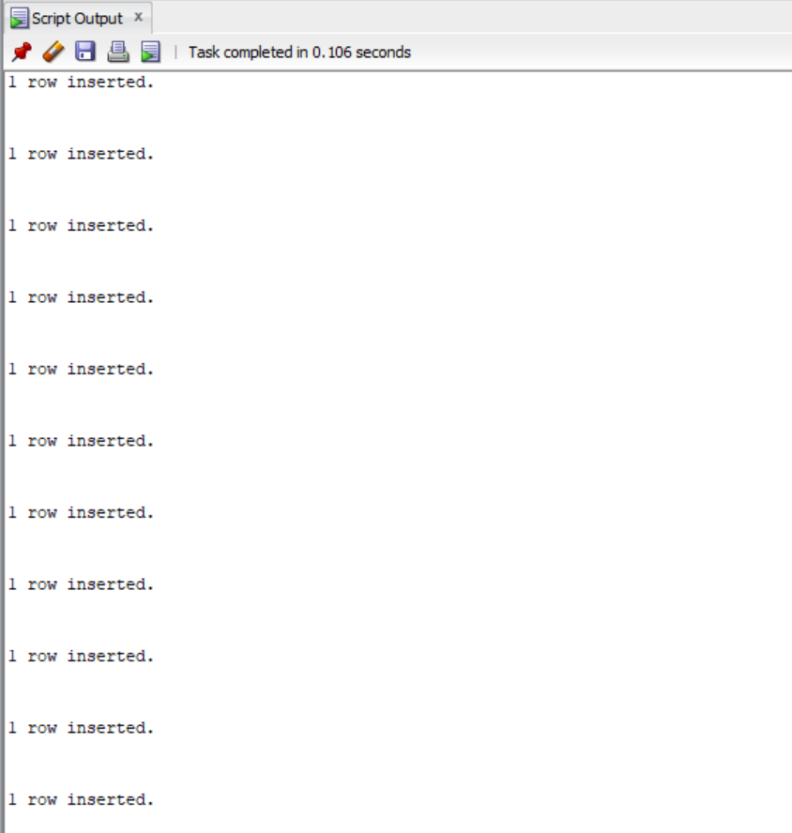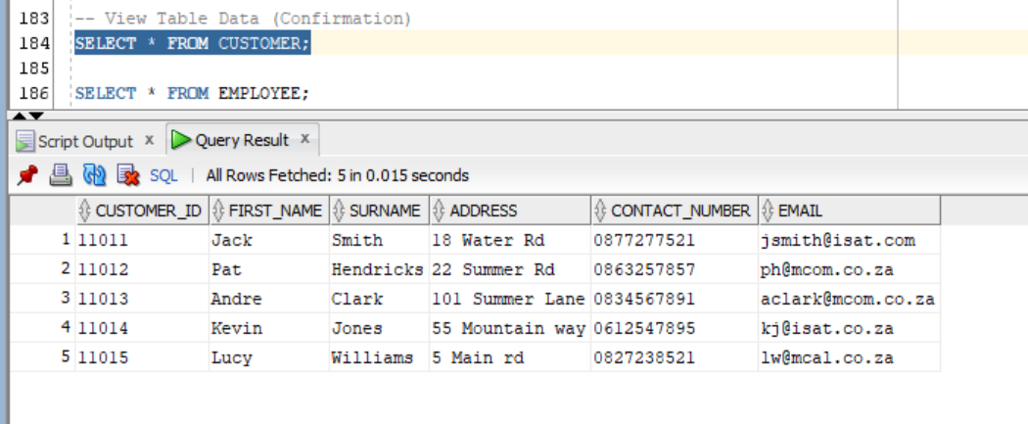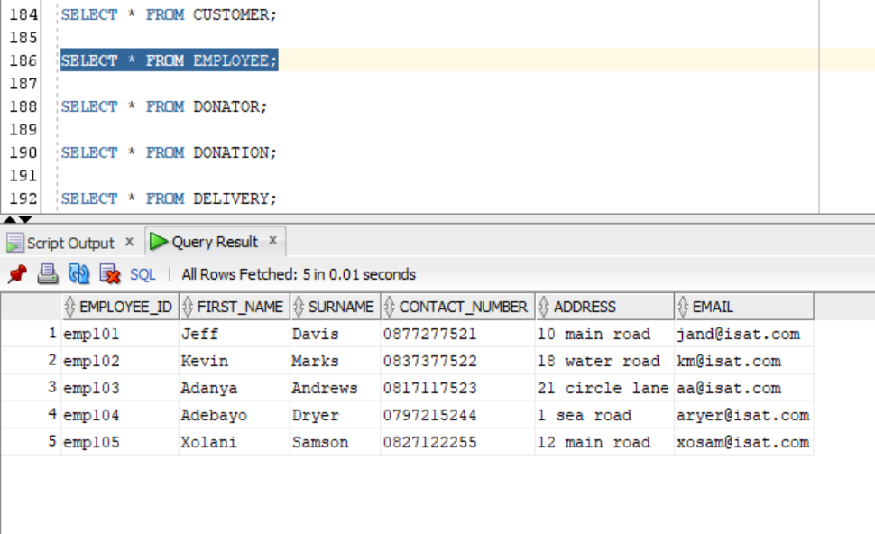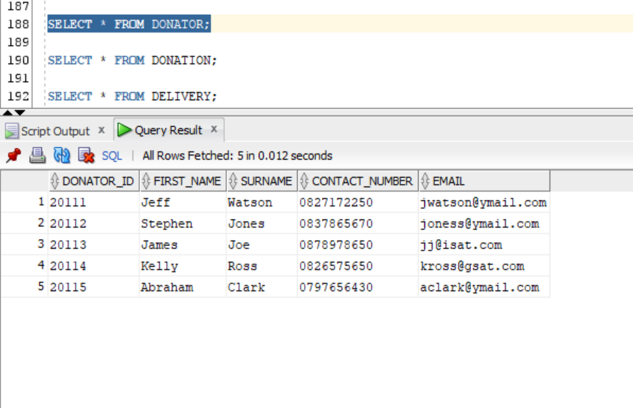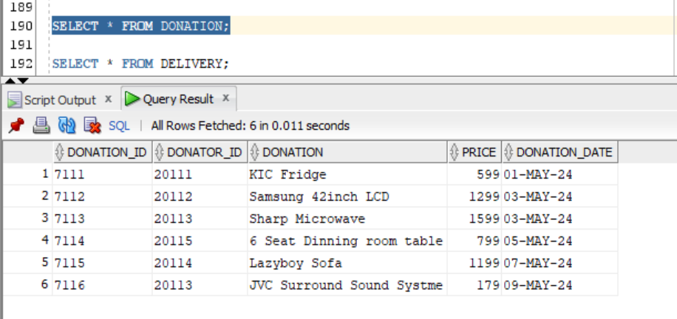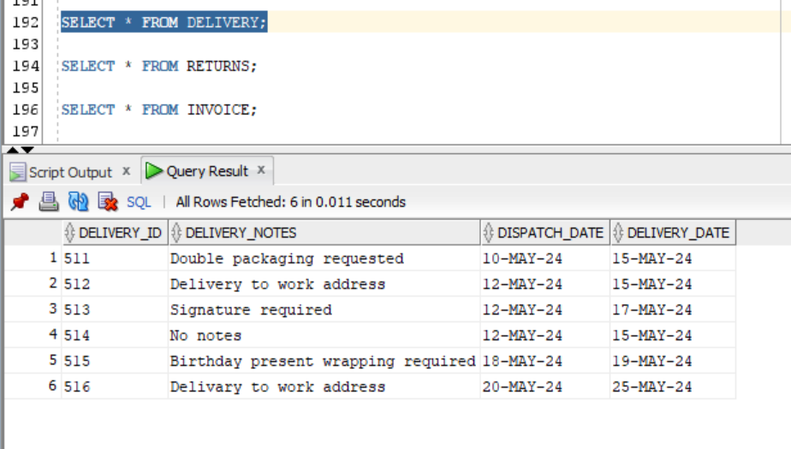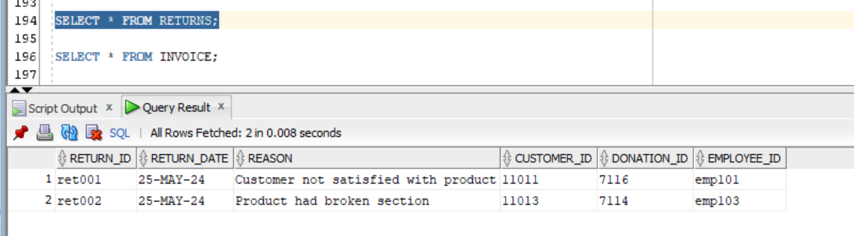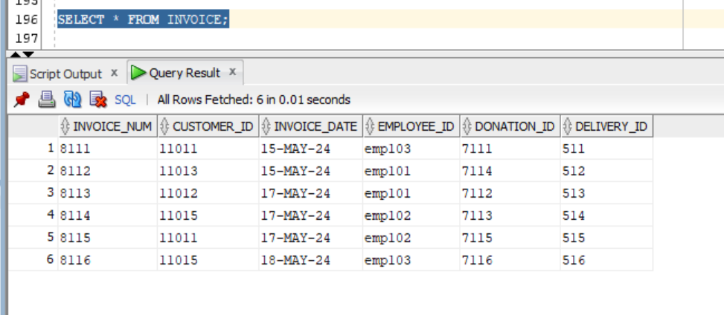
(IIE, 2024).

Question 2
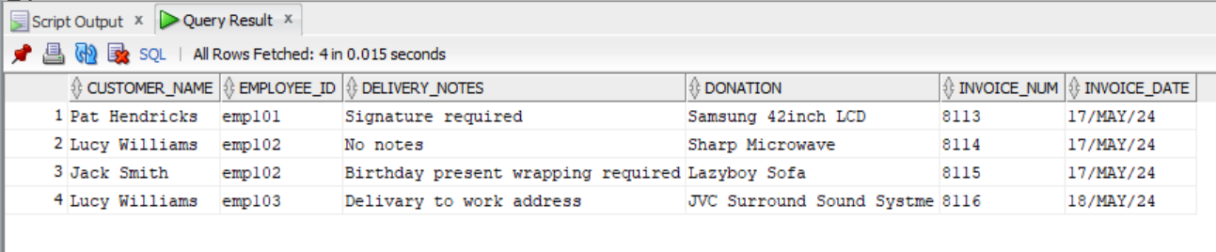
(IIE, 2024).

Question 3

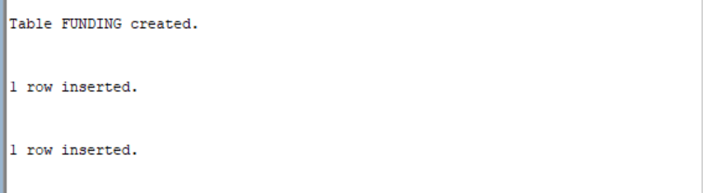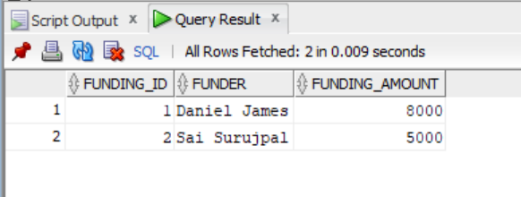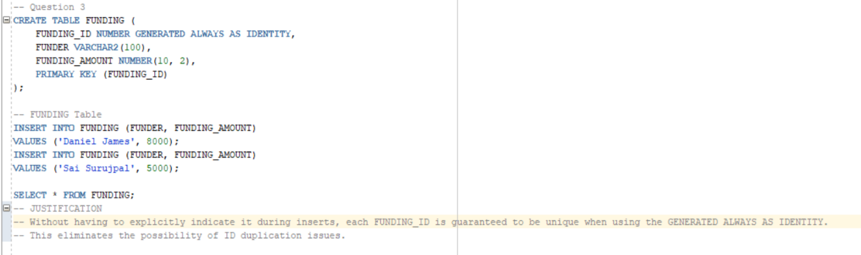
(IIE, 2024).

Question 4
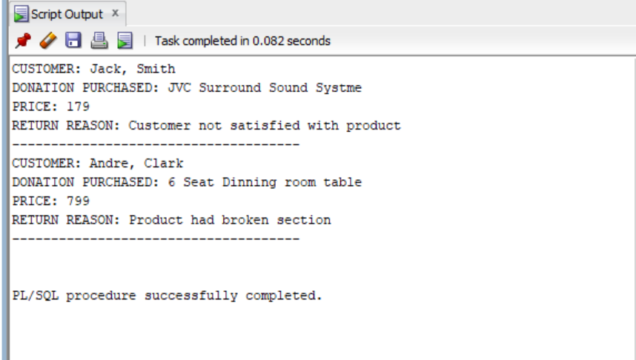
(IIE, 2024).

Question 5
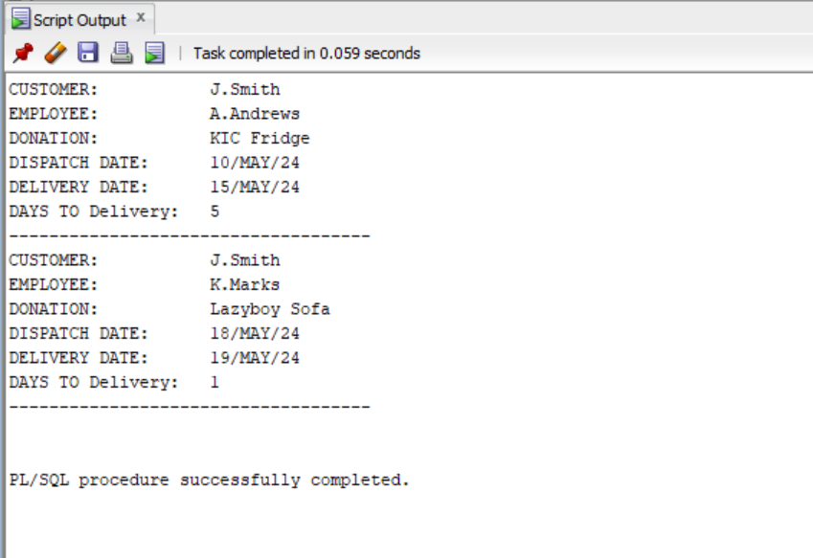
(IIE, 2024).

Question 6
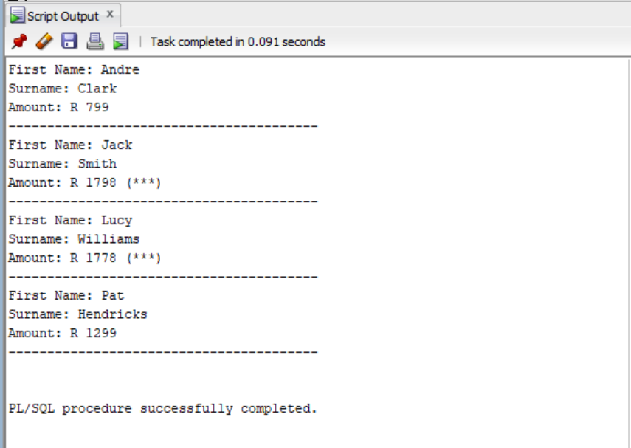
(IIE, 2024).

Question 7
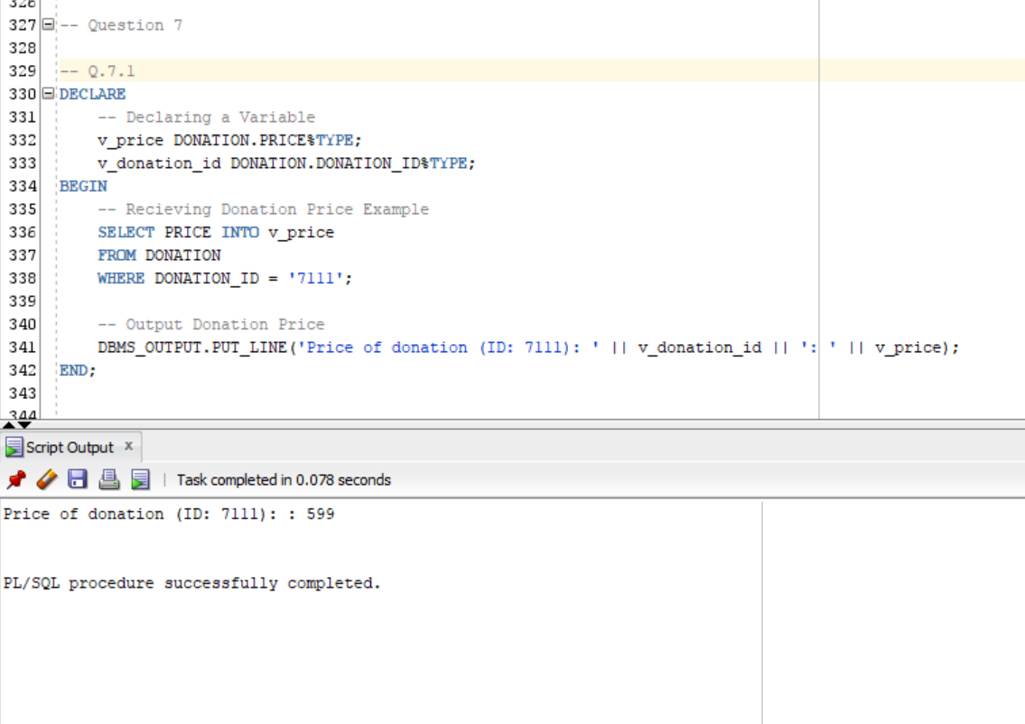 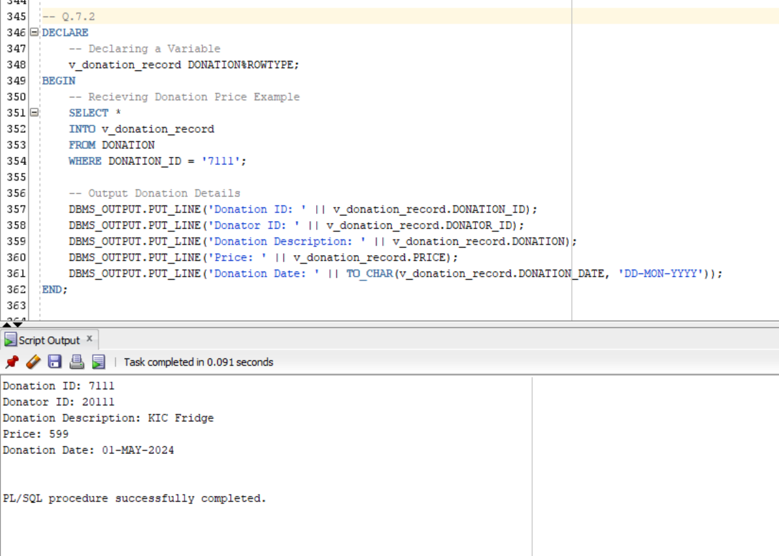 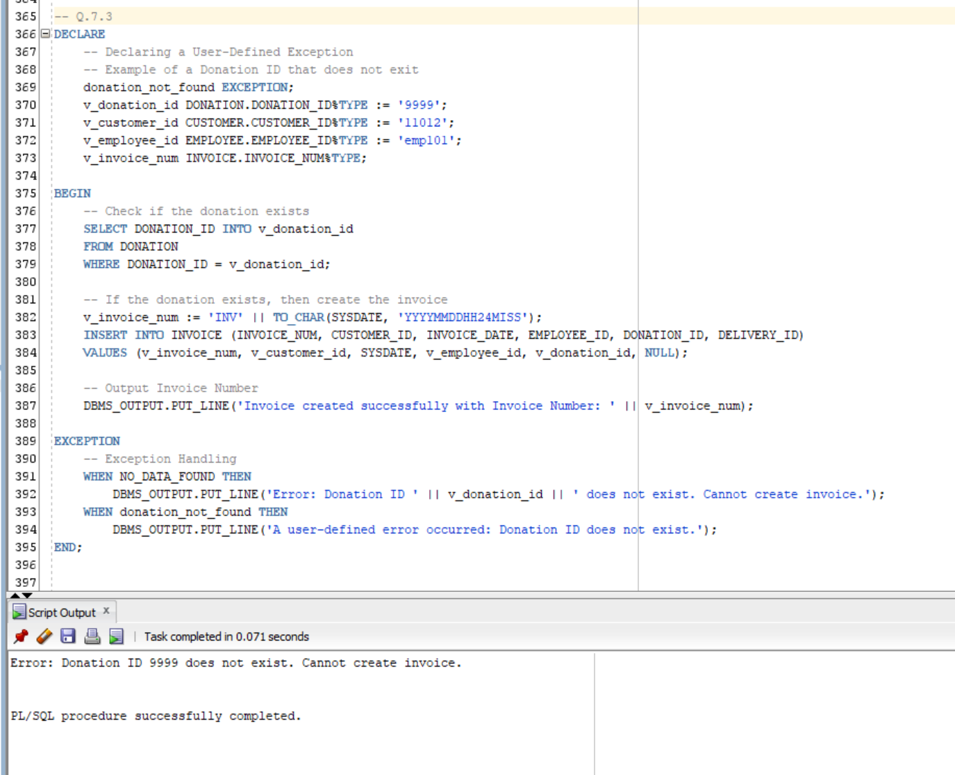 (IIE, 2024).

Question 8
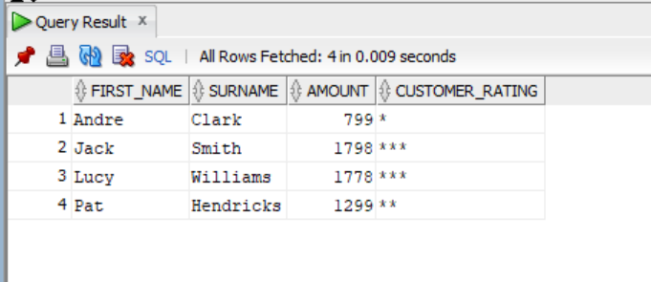
(IIE, 2024).

SQL Code
-- ST10393280 Daniel Luke James

-- Question 1
-- New database schema
CREATE DATABASE CHARITY4AFRICA_DBA;
USE CHARITY4AFRICA_DBA;

-- Create Tables
CREATE TABLE CUSTOMER (
CUSTOMER_ID VARCHAR2(10),
FIRST_NAME VARCHAR2(50),
SURNAME VARCHAR2(50),
ADDRESS VARCHAR2(100),
CONTACT_NUMBER VARCHAR2(20),
EMAIL VARCHAR2(50),
PRIMARY KEY (CUSTOMER_ID)
);

CREATE TABLE EMPLOYEE (
EMPLOYEE_ID VARCHAR2(10),
FIRST_NAME VARCHAR2(50),
SURNAME VARCHAR2(50),
CONTACT_NUMBER VARCHAR2(20),
ADDRESS VARCHAR2(100),
EMAIL VARCHAR2(50),
PRIMARY KEY (EMPLOYEE_ID)
);

CREATE TABLE DONATOR (
DONATOR_ID VARCHAR2(10),
FIRST_NAME VARCHAR2(50),
SURNAME VARCHAR2(50),
CONTACT_NUMBER VARCHAR2(20),
EMAIL VARCHAR2(50),
PRIMARY KEY (DONATOR_ID)
);

CREATE TABLE DONATION (
DONATION_ID VARCHAR2(10),
DONATOR_ID VARCHAR2(10),
DONATION VARCHAR2(100),
PRICE NUMBER(10, 2),
DONATION_DATE DATE,
PRIMARY KEY (DONATION_ID),
FOREIGN KEY (DONATOR_ID) REFERENCES DONATOR(DONATOR_ID)
);

CREATE TABLE DELIVERY (
DELIVERY_ID VARCHAR2(10),
DELIVERY_NOTES VARCHAR2(200),
DISPATCH_DATE DATE,
DELIVERY_DATE DATE,
PRIMARY KEY (DELIVERY_ID)
);

CREATE TABLE RETURNS (
RETURN_ID VARCHAR2(10),
RETURN_DATE DATE,
REASON VARCHAR2(200),
CUSTOMER_ID VARCHAR2(10),
DONATION_ID VARCHAR2(10),
EMPLOYEE_ID VARCHAR2(10),
PRIMARY KEY (RETURN_ID),
FOREIGN KEY (CUSTOMER_ID) REFERENCES CUSTOMER(CUSTOMER_ID),
FOREIGN KEY (DONATION_ID) REFERENCES DONATION(DONATION_ID),
FOREIGN KEY (EMPLOYEE_ID) REFERENCES EMPLOYEE(EMPLOYEE_ID)
);

CREATE TABLE INVOICE (
INVOICE_NUM VARCHAR2(10),
CUSTOMER_ID VARCHAR2(10),
INVOICE_DATE DATE,
EMPLOYEE_ID VARCHAR2(10),
DONATION_ID VARCHAR2(10),
DELIVERY_ID VARCHAR2(10),
PRIMARY KEY (INVOICE_NUM),
FOREIGN KEY (CUSTOMER_ID) REFERENCES CUSTOMER(CUSTOMER_ID),
FOREIGN KEY (EMPLOYEE_ID) REFERENCES EMPLOYEE(EMPLOYEE_ID),
FOREIGN KEY (DONATION_ID) REFERENCES DONATION(DONATION_ID),
FOREIGN KEY (DELIVERY_ID) REFERENCES DELIVERY(DELIVERY_ID)
);

-- Insert Data

-- CUSTOMER Table
INSERT INTO CUSTOMER (CUSTOMER_ID, FIRST_NAME, SURNAME, ADDRESS, CONTACT_NUMBER, EMAIL)
VALUES ('11011', 'Jack', 'Smith', '18 Water Rd', '0877277521', 'jsmith@isat.com');
INSERT INTO CUSTOMER (CUSTOMER_ID, FIRST_NAME, SURNAME, ADDRESS, CONTACT_NUMBER, EMAIL)
VALUES ('11012', 'Pat', 'Hendricks', '22 Summer Rd', '0863257857', 'ph@mcom.co.za');
INSERT INTO CUSTOMER (CUSTOMER_ID, FIRST_NAME, SURNAME, ADDRESS, CONTACT_NUMBER, EMAIL)
VALUES ('11013', 'Andre', 'Clark', '101 Summer Lane', '0834567891', 'aclark@mcom.co.za');
INSERT INTO CUSTOMER (CUSTOMER_ID, FIRST_NAME, SURNAME, ADDRESS, CONTACT_NUMBER, EMAIL)
VALUES ('11014', 'Kevin', 'Jones', '55 Mountain way', '0612547895', 'kj@isat.co.za');
INSERT INTO CUSTOMER (CUSTOMER_ID, FIRST_NAME, SURNAME, ADDRESS, CONTACT_NUMBER, EMAIL)
VALUES ('11015', 'Lucy', 'Williams', '5 Main rd', '0827238521', 'lw@mcal.co.za');

-- EMPLOYEE Table
INSERT INTO EMPLOYEE (EMPLOYEE_ID, FIRST_NAME, SURNAME, CONTACT_NUMBER, ADDRESS, EMAIL)
VALUES ('emp101', 'Jeff', 'Davis', '0877277521', '10 main road', 'jand@isat.com');
INSERT INTO EMPLOYEE (EMPLOYEE_ID, FIRST_NAME, SURNAME, CONTACT_NUMBER, ADDRESS, EMAIL)
VALUES ('emp102', 'Kevin', 'Marks', '0837377522', '18 water road', 'km@isat.com');
INSERT INTO EMPLOYEE (EMPLOYEE_ID, FIRST_NAME, SURNAME, CONTACT_NUMBER, ADDRESS, EMAIL)
VALUES ('emp103', 'Adanya', 'Andrews', '0817117523', '21 circle lane', 'aa@isat.com');
INSERT INTO EMPLOYEE (EMPLOYEE_ID, FIRST_NAME, SURNAME, CONTACT_NUMBER, ADDRESS, EMAIL)
VALUES ('emp104', 'Adebayo', 'Dryer', '0797215244', '1 sea road', 'aryer@isat.com');
INSERT INTO EMPLOYEE (EMPLOYEE_ID, FIRST_NAME, SURNAME, CONTACT_NUMBER, ADDRESS, EMAIL)
VALUES ('emp105', 'Xolani', 'Samson', '0827122255', '12 main road', 'xosam@isat.com');

-- DONATOR Table
INSERT INTO DONATOR (DONATOR_ID, FIRST_NAME, SURNAME, CONTACT_NUMBER, EMAIL)
VALUES ('20111', 'Jeff', 'Watson', '0827172250', 'jwatson@ymail.com');
INSERT INTO DONATOR (DONATOR_ID, FIRST_NAME, SURNAME, CONTACT_NUMBER, EMAIL)
VALUES ('20112', 'Stephen', 'Jones', '0837865670', 'joness@ymail.com');
INSERT INTO DONATOR (DONATOR_ID, FIRST_NAME, SURNAME, CONTACT_NUMBER, EMAIL)
VALUES ('20113', 'James', 'Joe', '0878978650', 'jj@isat.com');
INSERT INTO DONATOR (DONATOR_ID, FIRST_NAME, SURNAME, CONTACT_NUMBER, EMAIL)
VALUES ('20114', 'Kelly', 'Ross', '0826575650', 'kross@gsat.com');
INSERT INTO DONATOR (DONATOR_ID, FIRST_NAME, SURNAME, CONTACT_NUMBER, EMAIL)
VALUES ('20115', 'Abraham', 'Clark', '0797656430', 'aclark@ymail.com');

-- DONATION Table
INSERT INTO DONATION (DONATION_ID, DONATOR_ID, DONATION, PRICE, DONATION_DATE)
VALUES ('7111', '20111', 'KIC Fridge', 599, TO_DATE('1-MAY-2024', 'DD-MON-YYYY'));
INSERT INTO DONATION (DONATION_ID, DONATOR_ID, DONATION, PRICE, DONATION_DATE)
VALUES ('7112', '20112', 'Samsung 42inch LCD', 1299, TO_DATE('3-MAY-2024', 'DD-MON-YYYY'));
INSERT INTO DONATION (DONATION_ID, DONATOR_ID, DONATION, PRICE, DONATION_DATE)
VALUES ('7113', '20113', 'Sharp Microwave', 1599, TO_DATE('3-MAY-2024', 'DD-MON-YYYY'));
INSERT INTO DONATION (DONATION_ID, DONATOR_ID, DONATION, PRICE, DONATION_DATE)
VALUES ('7114', '20115', '6 Seat Dinning room table', 799, TO_DATE('5-MAY-2024', 'DD-MON-YYYY'));
INSERT INTO DONATION (DONATION_ID, DONATOR_ID, DONATION, PRICE, DONATION_DATE)
VALUES ('7115', '20114', 'Lazyboy Sofa', 1199, TO_DATE('7-MAY-2024', 'DD-MON-YYYY'));
INSERT INTO DONATION (DONATION_ID, DONATOR_ID, DONATION, PRICE, DONATION_DATE)
VALUES ('7116', '20113', 'JVC Surround Sound Systme', 179, TO_DATE('9-MAY-2024', 'DD-MON-YYYY'));

-- DELIVERY Table
INSERT INTO DELIVERY (DELIVERY_ID, DELIVERY_NOTES, DISPATCH_DATE, DELIVERY_DATE)
VALUES ('511', 'Double packaging requested', TO_DATE('10-MAY-2024', 'DD-MON-YYYY'), TO_DATE('15-MAY-2024', 'DD-MON-YYYY'));
INSERT INTO DELIVERY (DELIVERY_ID, DELIVERY_NOTES, DISPATCH_DATE, DELIVERY_DATE)
VALUES ('512', 'Delivery to work address', TO_DATE('12-MAY-2024', 'DD-MON-YYYY'), TO_DATE('15-MAY-2024', 'DD-MON-YYYY'));
INSERT INTO DELIVERY (DELIVERY_ID, DELIVERY_NOTES, DISPATCH_DATE, DELIVERY_DATE)
VALUES ('513', 'Signature required', TO_DATE('12-MAY-2024', 'DD-MON-YYYY'), TO_DATE('17-MAY-2024', 'DD-MON-YYYY'));
INSERT INTO DELIVERY (DELIVERY_ID, DELIVERY_NOTES, DISPATCH_DATE, DELIVERY_DATE)
VALUES ('514', 'No notes', TO_DATE('12-MAY-2024', 'DD-MON-YYYY'), TO_DATE('15-MAY-2024', 'DD-MON-YYYY'));
INSERT INTO DELIVERY (DELIVERY_ID, DELIVERY_NOTES, DISPATCH_DATE, DELIVERY_DATE)
VALUES ('515', 'Birthday present wrapping required', TO_DATE('18-MAY-2024', 'DD-MON-YYYY'), TO_DATE('19-MAY-2024', 'DD-MON-YYYY'));
INSERT INTO DELIVERY (DELIVERY_ID, DELIVERY_NOTES, DISPATCH_DATE, DELIVERY_DATE)
VALUES ('516', 'Delivary to work address', TO_DATE('20-MAY-2024', 'DD-MON-YYYY'), TO_DATE('25-MAY-2024', 'DD-MON-YYYY'));

-- RETURNS Table
INSERT INTO RETURNS (RETURN_ID, RETURN_DATE, REASON, CUSTOMER_ID, DONATION_ID, EMPLOYEE_ID)
VALUES ('ret001', TO_DATE('25-MAY-2024', 'DD-MON-YYYY'), 'Customer not satisfied with product', '11011', '7116', 'emp101');
INSERT INTO RETURNS (RETURN_ID, RETURN_DATE, REASON, CUSTOMER_ID, DONATION_ID, EMPLOYEE_ID)
VALUES ('ret002', TO_DATE('25-MAY-2024', 'DD-MON-YYYY'), 'Product had broken section', '11013', '7114', 'emp103');

-- INVOICE Table
INSERT INTO INVOICE (INVOICE_NUM, CUSTOMER_ID, INVOICE_DATE, EMPLOYEE_ID, DONATION_ID, DELIVERY_ID)
VALUES ('8111', '11011', TO_DATE('15-MAY-2024', 'DD-MON-YYYY'), 'emp103', '7111', '511');
INSERT INTO INVOICE (INVOICE_NUM, CUSTOMER_ID, INVOICE_DATE, EMPLOYEE_ID, DONATION_ID, DELIVERY_ID)
VALUES ('8112', '11013', TO_DATE('15-MAY-2024', 'DD-MON-YYYY'), 'emp101', '7114', '512');
INSERT INTO INVOICE (INVOICE_NUM, CUSTOMER_ID, INVOICE_DATE, EMPLOYEE_ID, DONATION_ID, DELIVERY_ID)
VALUES ('8113', '11012', TO_DATE('17-MAY-2024', 'DD-MON-YYYY'), 'emp101', '7112', '513');
INSERT INTO INVOICE (INVOICE_NUM, CUSTOMER_ID, INVOICE_DATE, EMPLOYEE_ID, DONATION_ID, DELIVERY_ID)
VALUES ('8114', '11015', TO_DATE('17-MAY-2024', 'DD-MON-YYYY'), 'emp102', '7113', '514');
INSERT INTO INVOICE (INVOICE_NUM, CUSTOMER_ID, INVOICE_DATE, EMPLOYEE_ID, DONATION_ID, DELIVERY_ID)
VALUES ('8115', '11011', TO_DATE('17-MAY-2024', 'DD-MON-YYYY'), 'emp102', '7115', '515');
INSERT INTO INVOICE (INVOICE_NUM, CUSTOMER_ID, INVOICE_DATE, EMPLOYEE_ID, DONATION_ID, DELIVERY_ID)
VALUES ('8116', '11015', TO_DATE('18-MAY-2024', 'DD-MON-YYYY'), 'emp103', '7116', '516');

-- View Table Data (Confirmation)
SELECT * FROM CUSTOMER;

SELECT * FROM EMPLOYEE;

SELECT * FROM DONATOR;

SELECT * FROM DONATION;

SELECT * FROM DELIVERY;

SELECT * FROM RETURNS;

SELECT * FROM INVOICE;

-- Question 2
SELECT
CUSTOMER.FIRST_NAME || ' ' || CUSTOMER.SURNAME AS CUSTOMER_NAME,
INVOICE.EMPLOYEE_ID,
DELIVERY.DELIVERY_NOTES,
DONATION.DONATION,
INVOICE.INVOICE_NUM,
TO_CHAR(INVOICE.INVOICE_DATE, 'DD/MON/YY') AS INVOICE_DATE
FROM
CUSTOMER
JOIN INVOICE ON CUSTOMER.CUSTOMER_ID = INVOICE.CUSTOMER_ID
JOIN DELIVERY ON INVOICE.DELIVERY_ID = DELIVERY.DELIVERY_ID
JOIN DONATION ON INVOICE.DONATION_ID = DONATION.DONATION_ID
WHERE INVOICE.INVOICE_DATE > TO_DATE('16-MAY-2024', 'DD-MON-YYYY');

-- Question 3
CREATE TABLE FUNDING (
FUNDING_ID NUMBER GENERATED ALWAYS AS IDENTITY,
FUNDER VARCHAR2(100),
FUNDING_AMOUNT NUMBER(10, 2),
PRIMARY KEY (FUNDING_ID)
);

-- FUNDING Table
INSERT INTO FUNDING (FUNDER, FUNDING_AMOUNT)
VALUES ('Daniel James', 8000);
INSERT INTO FUNDING (FUNDER, FUNDING_AMOUNT)
VALUES ('Sai Surujpal', 5000);

SELECT * FROM FUNDING;
-- JUSTIFICATION
-- Without having to explicitly indicate it during inserts, each FUNDING_ID is guaranteed to be unique when using the GENERATED ALWAYS AS IDENTITY.
-- This eliminates the possibility of ID duplication issues.

-- Question 4
-- Enable server output
SET SERVEROUTPUT ON;

-- PL/SQL block
BEGIN
FOR rec IN (
SELECT
CUSTOMER.FIRST_NAME || ', ' || CUSTOMER.SURNAME AS CUSTOMER_NAME,
DONATION.DONATION,
DONATION.PRICE,
RETURNS.REASON
FROM
CUSTOMER
JOIN RETURNS ON CUSTOMER.CUSTOMER_ID = RETURNS.CUSTOMER_ID
JOIN DONATION ON RETURNS.DONATION_ID = DONATION.DONATION_ID
)
LOOP
DBMS_OUTPUT.PUT_LINE('CUSTOMER: ' || rec.CUSTOMER_NAME);
DBMS_OUTPUT.PUT_LINE('DONATION PURCHASED: ' || rec.DONATION);
DBMS_OUTPUT.PUT_LINE('PRICE: ' || rec.PRICE);
DBMS_OUTPUT.PUT_LINE('RETURN REASON: ' || rec.REASON);
DBMS_OUTPUT.PUT_LINE('-------------------------------------');
END LOOP;
END;
/

-- Question 5

-- Enable server output
SET SERVEROUTPUT ON;

-- PL/SQL block
BEGIN
FOR rec IN (
SELECT
SUBSTR(C.FIRST_NAME, 1, 1) || '.' || C.SURNAME AS CUSTOMER_NAME,
SUBSTR(E.FIRST_NAME, 1, 1) || '.' || E.SURNAME AS EMPLOYEE_NAME,
D.DONATION,
DL.DISPATCH_DATE,
DL.DELIVERY_DATE,
(DL.DELIVERY_DATE - DL.DISPATCH_DATE) AS DAYS_BETWEEN
FROM
CUSTOMER C
JOIN INVOICE I ON C.CUSTOMER_ID = I.CUSTOMER_ID
JOIN EMPLOYEE E ON I.EMPLOYEE_ID = E.EMPLOYEE_ID
JOIN DONATION D ON I.DONATION_ID = D.DONATION_ID
JOIN DELIVERY DL ON I.DELIVERY_ID = DL.DELIVERY_ID
WHERE
C.CUSTOMER_ID = '11011'
)
LOOP
DBMS_OUTPUT.PUT_LINE(RPAD('CUSTOMER: ', 20) || rec.CUSTOMER_NAME);
DBMS_OUTPUT.PUT_LINE(RPAD('EMPLOYEE: ', 20) || rec.EMPLOYEE_NAME);
DBMS_OUTPUT.PUT_LINE(RPAD('DONATION: ', 20) || rec.DONATION);
DBMS_OUTPUT.PUT_LINE(RPAD('DISPATCH DATE: ', 20) || TO_CHAR(rec.DISPATCH_DATE, 'DD/MON/YY'));
DBMS_OUTPUT.PUT_LINE(RPAD('DELIVERY DATE: ', 20) || TO_CHAR(rec.DELIVERY_DATE, 'DD/MON/YY'));
DBMS_OUTPUT.PUT_LINE(RPAD('DAYS TO Delivery: ', 20) || rec.DAYS_BETWEEN);
DBMS_OUTPUT.PUT_LINE('------------------------------------');
END LOOP;
END;
/

-- Question 6

-- Enable server output
SET SERVEROUTPUT ON;

-- PL/SQL block
BEGIN
FOR rec IN (
SELECT
c.FIRST_NAME AS FIRST_NAME,
c.SURNAME AS SURNAME,
SUM(d.PRICE) AS TOTAL_AMOUNT
FROM
CUSTOMER c
JOIN
INVOICE i ON c.CUSTOMER_ID = i.CUSTOMER_ID
JOIN
DONATION d ON i.DONATION_ID = d.DONATION_ID
GROUP BY
c.FIRST_NAME, c.SURNAME
ORDER BY
c.FIRST_NAME, c.SURNAME
) LOOP
DBMS_OUTPUT.PUT_LINE('First Name: ' || rec.FIRST_NAME);
DBMS_OUTPUT.PUT_LINE('Surname: ' || rec.SURNAME);

IF rec.TOTAL_AMOUNT >= 1500 THEN
DBMS_OUTPUT.PUT_LINE('Amount: R ' || rec.TOTAL_AMOUNT || ' (***)');
ELSE
DBMS_OUTPUT.PUT_LINE('Amount: R ' || rec.TOTAL_AMOUNT);
END IF;

DBMS_OUTPUT.PUT_LINE('----------------------------------------');
END LOOP;
END;
/

-- Question 7

-- Q.7.1
DECLARE
-- Declaring a Variable
v_price DONATION.PRICE%TYPE;
v_donation_id DONATION.DONATION_ID%TYPE;
BEGIN
-- Recieving Donation Price Example
SELECT PRICE INTO v_price
FROM DONATION
WHERE DONATION_ID = '7111';

-- Output Donation Price
DBMS_OUTPUT.PUT_LINE('Price of donation (ID: 7111): ' || v_donation_id || ': ' || v_price);
END;

-- Q.7.2
DECLARE
-- Declaring a Variable
v_donation_record DONATION%ROWTYPE;
BEGIN
-- Recieving Donation Price Example
SELECT *
INTO v_donation_record
FROM DONATION
WHERE DONATION_ID = '7111';

-- Output Donation Details
DBMS_OUTPUT.PUT_LINE('Donation ID: ' || v_donation_record.DONATION_ID);
DBMS_OUTPUT.PUT_LINE('Donator ID: ' || v_donation_record.DONATOR_ID);
DBMS_OUTPUT.PUT_LINE('Donation Description: ' || v_donation_record.DONATION);
DBMS_OUTPUT.PUT_LINE('Price: ' || v_donation_record.PRICE);
DBMS_OUTPUT.PUT_LINE('Donation Date: ' || TO_CHAR(v_donation_record.DONATION_DATE, 'DD-MON-YYYY'));
END;

-- Q.7.3
DECLARE
-- Declaring a User-Defined Exception
-- Example of a Donation ID that does not exit
donation_not_found EXCEPTION;
v_donation_id DONATION.DONATION_ID%TYPE := '9999';
v_customer_id CUSTOMER.CUSTOMER_ID%TYPE := '11012';
v_employee_id EMPLOYEE.EMPLOYEE_ID%TYPE := 'emp101';
v_invoice_num INVOICE.INVOICE_NUM%TYPE;

BEGIN
-- Check if the donation exists
SELECT DONATION_ID INTO v_donation_id
FROM DONATION
WHERE DONATION_ID = v_donation_id;

-- If the donation exists, then create the invoice
v_invoice_num := 'INV' || TO_CHAR(SYSDATE, 'YYYYMMDDHH24MISS');
INSERT INTO INVOICE (INVOICE_NUM, CUSTOMER_ID, INVOICE_DATE, EMPLOYEE_ID, DONATION_ID, DELIVERY_ID)
VALUES (v_invoice_num, v_customer_id, SYSDATE, v_employee_id, v_donation_id, NULL);

-- Output Invoice Number
DBMS_OUTPUT.PUT_LINE('Invoice created successfully with Invoice Number: ' || v_invoice_num);

EXCEPTION
-- Exception Handling
WHEN NO_DATA_FOUND THEN
DBMS_OUTPUT.PUT_LINE('Error: Donation ID ' || v_donation_id || ' does not exist. Cannot create invoice.');
WHEN donation_not_found THEN
DBMS_OUTPUT.PUT_LINE('A user-defined error occurred: Donation ID does not exist.');
END;

-- Question 8
SELECT
c.FIRST_NAME AS FIRST_NAME,
c.SURNAME AS SURNAME,
SUM(d.PRICE) AS AMOUNT,
CASE
WHEN SUM(d.PRICE) >= 1500 THEN '***'
WHEN SUM(d.PRICE) BETWEEN 1000 AND 1400 THEN '**'
ELSE '*'
END AS CUSTOMER_RATING
FROM
CUSTOMER c
JOIN
INVOICE i ON c.CUSTOMER_ID = i.CUSTOMER_ID
JOIN
DONATION d ON i.DONATION_ID = d.DONATION_ID
GROUP BY
c.FIRST_NAME, c.SURNAME
ORDER BY
c.FIRST_NAME, c.SURNAME;

ACADEMIC HONESTY DECLARATION

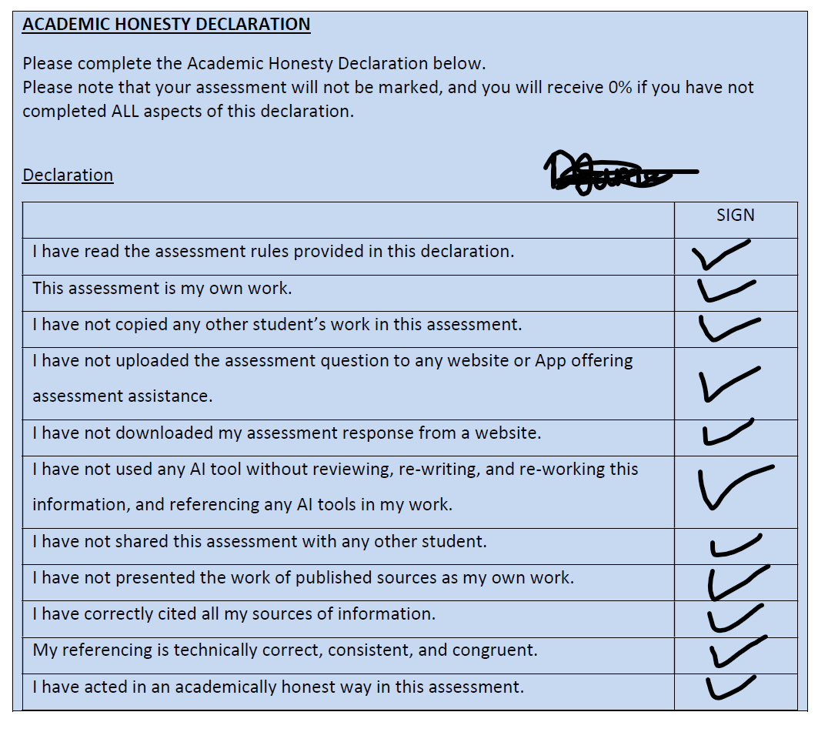
(IIE, 2024).

Reference List
- IIE. (2024). Advanced Databases Module Manual (First ed.) IIE.

**Note: I had to put the in-text referencing at the end of each question, as the images were moving around in a weird format. Thank you **

